
NOTE: This is an official document by Indexademics. Unless otherwise stated, this document may not be accredited to individuals or groups other than the club IDX, nor should this document be distributed, sold, or modified for personal use in any way.
IDX G9 GEOGRAPHY H STUDY GUIDE ISSUE 8
By Ethan, Edited by Heidi

—Salinity: concentration of dissolved salt in a solution. Seawater's average is 35 parts per thousand
—Brackish water: water that has a salinity of less than 35 parts per thousand
—Brine: a water that has a salinity of more than 35 parts per thousand
—Mixing zone: 2% of the oceanic mass. Solutes are blended here
—Thermocline transition zone: 18% of the oceanic mass. in the top two layers, temperature, salinity, and oxygen decrease. CO₂ increases here as you get lower.
—Deep cold zone: bottom 80% of the ocean. temperature and salinity values are uniform. Coldest water is at the bottom

Factors driving coastal systems
—Solar energy input drives the atmosphere and hydrosphere. Conversion of insolation to KE produces prevailing winds, weather systems, and climate.
—Winds generate ocean currents and waves
—Climatic regimes, which result from insolation and moisture, also influence coastal processes
—Coastal rock hardness. Hard rock is harder to erode than soft rock.
—Human activities also play a part

—Littoral zone: coastal area and shallow offshore environment
—Shoreline: line of contact between sea and land. shifts with tides etc.
—Intertidal zone: foreshore
—Mean sea level: value based on tidal levels recorded hourly over many years
—Tides: twice-daily oscillations in sea level
—Tidal bulges: fluid stretching caused by the moon's gravitational pull
—Flood tides: high tide
—Ebb tides: low tide
—Spring tide: when the sun and moon are on the same side of earth. highest ocean levels
—Neap tide: when the sun and moon are at right angles to the earth. high low tides and low high tides.
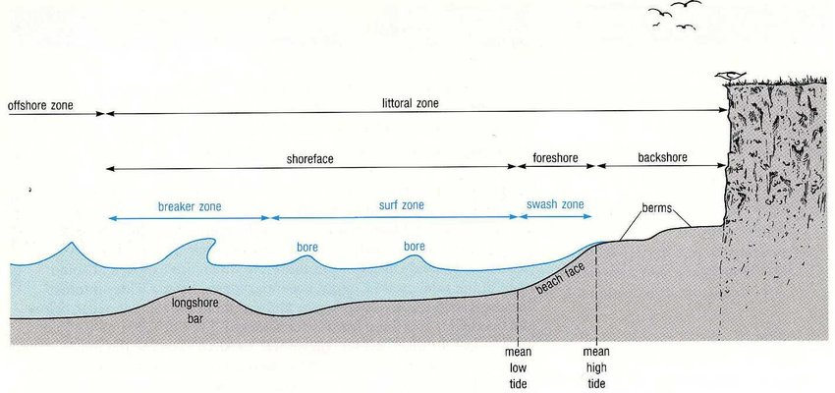
—Waves: undulations of water
—Wave trains: groups waves move in
—Swells: smooth, rounded waves.
—Wave energy: instead of the water itself moving, energy is transported through water
—Waves of transition: simple cyclic motions water moves in
—Waves of translation: when both energy and water moves towards shore
—Rip current: when backwash caused by breakers flows into the ocean from the beach in a concentrated column
—Interference: how much waves mess with each other
—if waves are in phase, height is amplified. If they are not, they become weaker

Possible Factors that Change Sea Level
--Tides and waves processes
--Long-term changes in global temperature and sea level

Zones of Wave Influence:
--breaker zone, surf zone, swash zone (≈foreshore)
Zones of Tide Influence:
--backshore, foreshore, nearshore
The Sediment Profile:
--berms, beach face, longshore bar

What Forces Drive Coastal Systems?
--Internal Forces:
--tectonic movement
--volcanic eruption & earthquake
--vegetation stabilization (e.g. mangroves, salt marshes, dune grasses trapping sediment)
--wide and long shelf (it reduces wave energy, and allows coast to build seaward)
--lithology (harder or softer rock on coasts) (e.g. limestone cliffs erode fast) (e.g. rocky/sandy/muddy/mangrove/coral-reef coasts)
--External Forces:
--atmospheric (wind, climate)
--ocean (waves/storms, tides, eustatic rise, currents)
--gravitational attraction (moon + earth + sun = tides)
--land (rivers) (size and type of sediment depends on river and distance of transport)

Types of Waves:
--wind waves (caused by wind)
--swell waves (caused by wind and then inertia)
--tsunami (caused by sudden and sharp motions in the seafloor – earthquakes, submarine landslides, or eruptions of undersea volcanoes)
--tidal waves (caused by gravitational force of the moon and sun)
--breakers/breaking waves (caused by friction of seabed)

Wind Waves:
--generated by winds in a stormy area at open ocean (known as fetch area)
--height of waves depends on wind velocity, duration, and fetch length
--wave height ranges from mm to over 100 ft
--KE and PE of waves increase in the fetch area

Swell Waves:
--travelled outside of fetch area → not affected by wind anymore but keeps moving due to inertia
--becomes smooth, round-shaped, long-crested because of the friction between air and water
--uniformly symmetrical waves, little loss of energy

Tsunamis:
--triggered by sudden and sharp motions in the seafloor, hard to detect or forecast
--3 in. to 1 m tall in open sea, length can reach over 100 km
--travel at a great speed (600-800 km/h)
-- get much taller and shorter in length when approaching shore

Breaking Waves:
--Spilling Breakers:
--forms on flat/gentle seafloor → gentle waves
--wave energy slowly dissipates
--Plunging Breakers:
--steeper seafloor or sudden depth changes
--crest becomes vertical and then curls over; releases most of its energy at once
--Surging Breakers:
--when low steepness waves meet very steep beach
--crests remain relatively unbroken as waves slide up the beach

Constructive Waves:
--deposits more sediment than it erodes; stronger swash
Destructive Waves:
--erodes more sediment than it deposits; stronger backwash

